1. ER Diagram

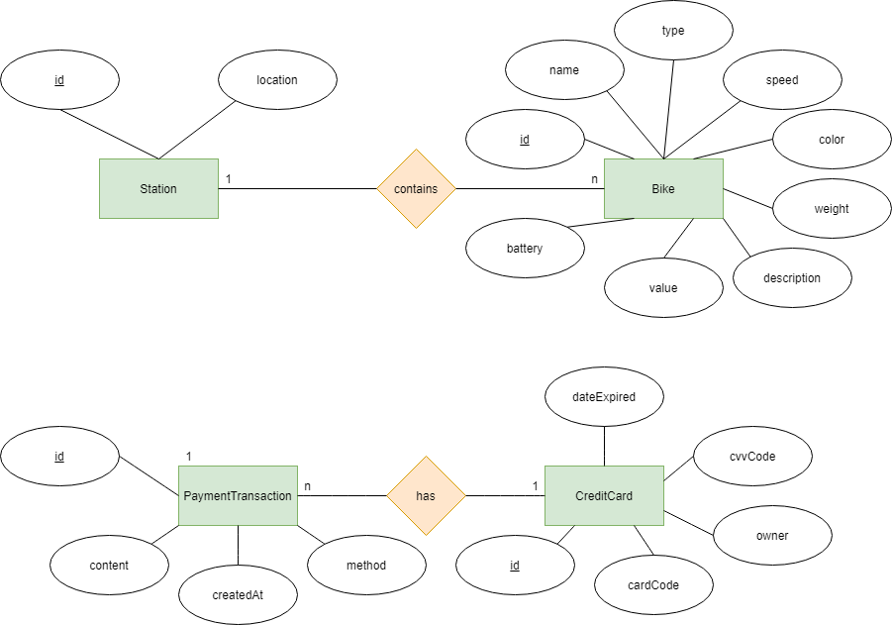

1. Logical Data Model

Station {

id : String

location : String

bikeId: String[]

}

Bike {

id: String

name: String

speed: float

type: String

color: String[]

weight: float

description: String

value: int

battery: int

docked_station_id : String

}

CreditCard {

id: int

cardCode: String

owner: String

cvvCode: String

dateExpired: String

}

PaymentTransaction {

id: int

createAt: Date

amount: int

creditCard: {

cardCode: String

owner: String

cvvCode: String

dateExpired: String

}

method: String

content: String

}

1. Physical Data Model ( NoSQL-MongoDB)

use database

1. Station

|  |  |  |  |  |  |  |
| --- | --- | --- | --- | --- | --- | --- |
| # | PK | FK | Name | Data Type | Mandatory | Description |
| 1 | V |  | Id | String | Yes | ID |
| 2 |  |  | location | String | Yes | Location of the station |
| 3 |  | v | bikeId | String[] | no | Id of the bikes in the station. A station maybe empty |

db.createCollection(station)

1. Bike

|  |  |  |  |  |  |  |
| --- | --- | --- | --- | --- | --- | --- |
| # | PK | FK | Name | Data Type | Mandatory | Description |
| 1 | V |  | Id | String | Yes | ID |
| 2 |  |  | name | String | yes | Bike name |
| 3 |  |  | speed | float | Yes | Max speed |
| 4 |  |  | type | String | Yes | Bike,ebike,… |
| 5 |  |  | color | String[] | Yes | Bike color |
| 6 |  |  | weight | float | Yes | Bike weight |
| 7 |  |  | description | String | no | Bike description |
| 8 |  |  | value | int |  | The value of the bike |
| 9 |  |  | battery | int | no | Only Ebike has |
| 10 |  | v | stationId | String | no | The station the bike currently in, null if the bike is currently rented |

db.createCollection(bike)

1. CreditCard

|  |  |  |  |  |  |  |
| --- | --- | --- | --- | --- | --- | --- |
| # | PK | FK | Column name | Data type | Mandatory | Description |
| 1 | x |  | cardCode | String | Yes | Card code |
| 2 |  |  | owner | String | Yes | Card holder |
| 3 |  |  | cvvCode | String | Yes | Card cvv code (security number) |
| 4 |  |  | dateExpired | String | Yes | Expired date |

db.createCollection(creditCard)

1. PaymentTransaction.

|  |  |  |  |  |  |  |
| --- | --- | --- | --- | --- | --- | --- |
| # | PK | FK | Name | Data type | Mandatory | Description |
| 1 | X |  | id | int | Yes | ID |
| 2 |  |  | createAt | Date | Yes | Date of creation |
| 3 |  |  | amount | int | Yes | Amount of money involve in the transaction |
| 4 |  | X | creditCard | Object | Yes | Used credit card |
| 5 |  |  | method | String | Yes | Payment method |
| 6 |  |  | content | String | Yes | Payment content |

db.createCollection(paymentTransaction)